Spring Boot provides a good **default implementation for handling error** **and exceptions** but still as per client’s requirement, we need to structure REST API error response to the client.

1. 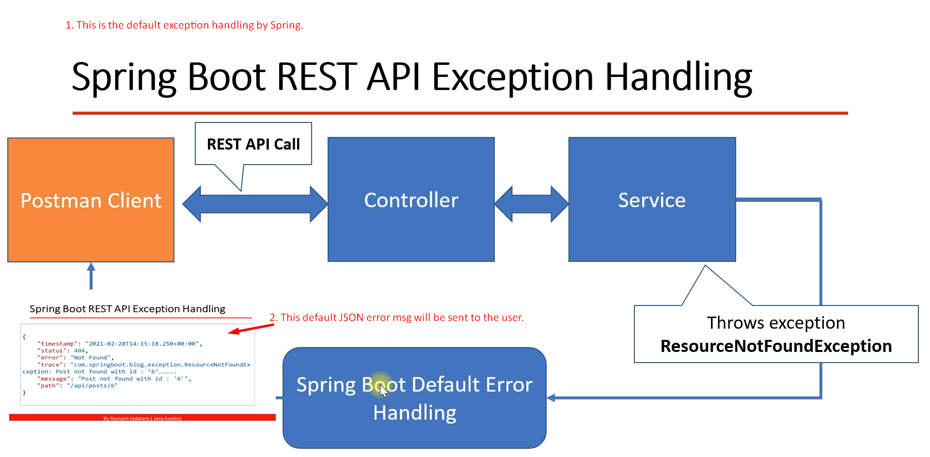  
   NOTE: You may think why 404 even though the server received the request but some exception occurred over server?  
   Well, in REST API, 404 means there is something wrong with request as it is asking for resource which is not present with server.
2. 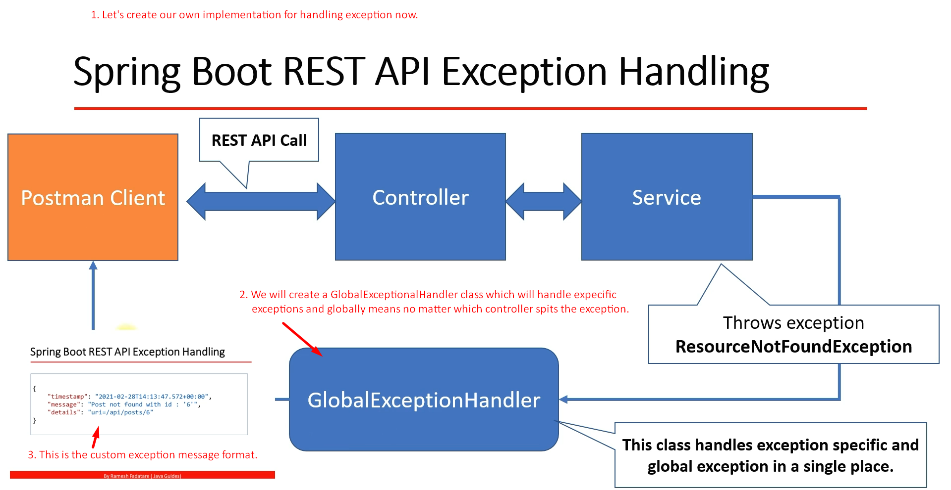
3. 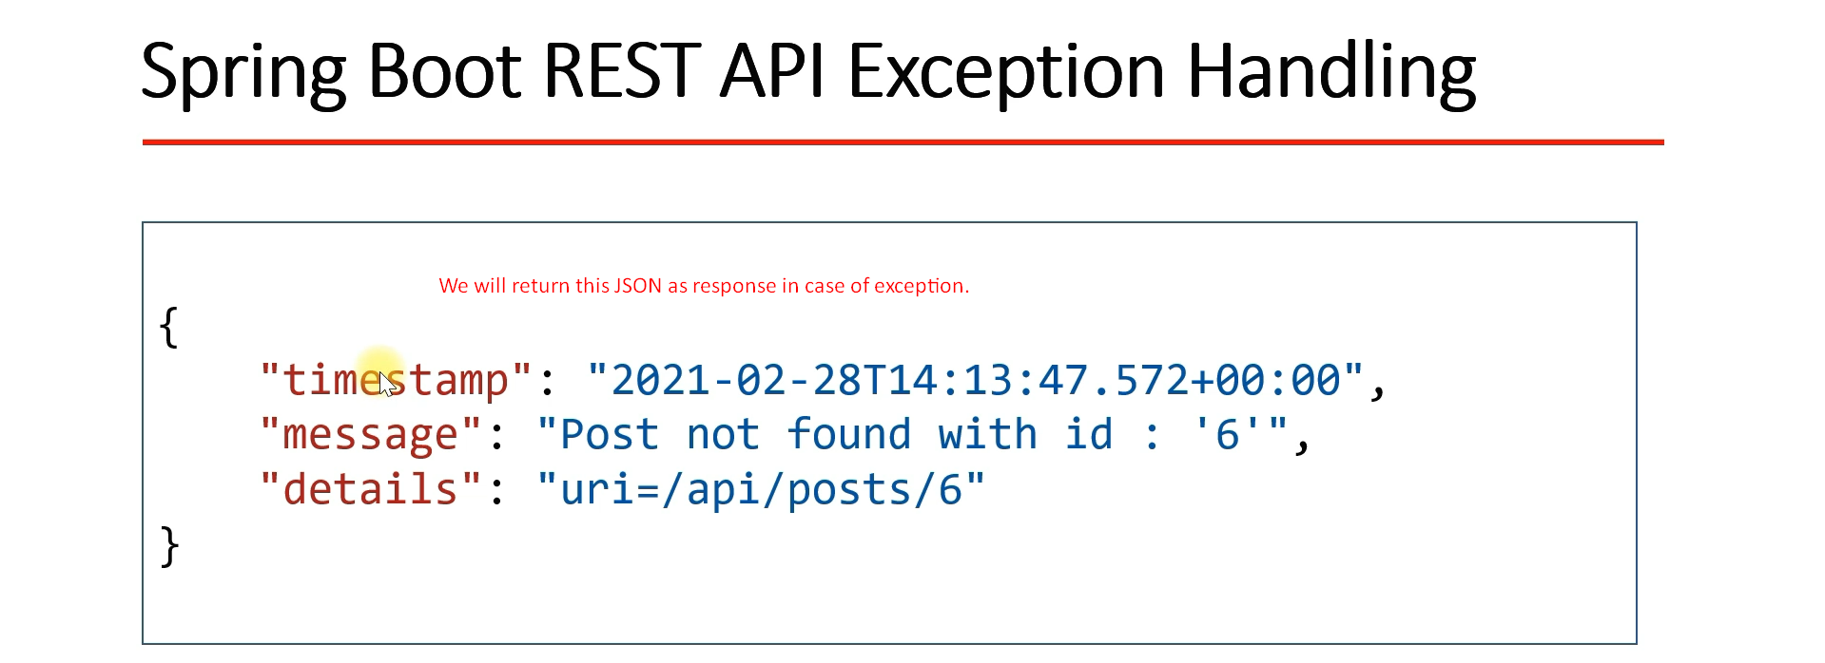
4. 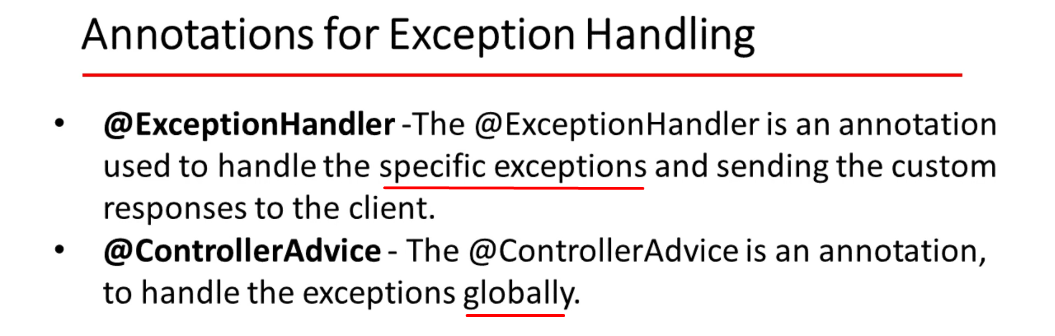
5. 